***Assignment – 1***

**1. Write an algorithm, flowchart and pseudocode to find area of a rectangle.**

**Algorithm:**

**Step 1:** Start

**Step 2:** get l, b values

**Step 3:** Calculate A=l*b

**Step 4:** Display A

**Step 5:** Stop

**Flowchart:**

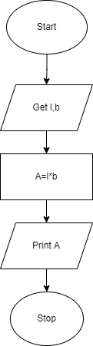

**Pseudocode:**

BEGIN

READ l, b

CALCULATE A=l*b

DISPLAY A

END

**2. Write an algorithm, flowchart and pseudocode for Calculating area and circumference of circle.**

**Algorithm:**

**Step 1:** Start

**Step 2:** get r value

**Step 3:** Calculate A=3.14*r*r

**Step 4:** Calculate C=2*3.14*r

**Step 5:** Display A, C

**Step 6:** Stop

**Flowchart:**

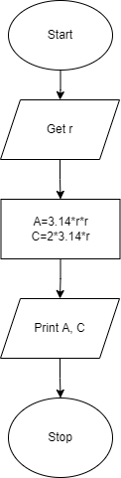

**Pseudocode:**

BEGIN

READ r

CALCULATE A and C

A=3.14*r*r

C=2*3.14*r

DISPLAY A

END

**3.Write an algorithm flowchart and pseudocode for Calculating simple interest.**

**Algorithm:**

**Step 1:** Start

**Step 2:** get p, n, r value

**Step3:** Calculate SI=(p*n*r)/100

**Step 4:** Display S

**Step 5:** Stop

**Flowchart:**

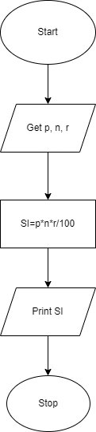

**Pseudocode:**

BEGIN

READ P, n, r

CALCULATE S

SI=(p*n*r)/100

DISPLAY SI

END

**4. Write an algorithm, flowchart and pseudocode for Calculating engineering cut-off.**

**Algorithm:**

**Step 1:** Start

**Step2:** get P, C, M value

**Step3:** calculate Cut-off= (P/4+C/4+M/2)

**Step 4:** Display Cut-off

**Step 5:** Stop

**Flowchart**:

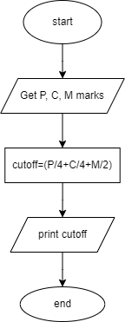

**Pseudocode:**

BEGIN

READ P, C, M

CALCULATE

Cut-off= (P/4+C/4+M/2)

DISPLAY Cut-off

END

**5. Write an algorithm, flowchart and pseudocode for to check greatest of two numbers.**

**Algorithm:**

**Step 1:** Start

**Step 2:** get a, b value

**Step 3:** check if(a>b) print a is greater

**Step 4:** else b is greater

**Step 5:** Stop

**Flowchart:**

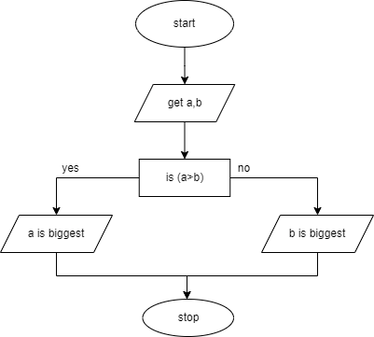**Pseudocode:**

BEGIN

READ a, b

IF (a>b) THEN

DISPLAY a is greater

ELSE

DISPLAY b is greater

END IF

END

**6. Write an algorithm, flowchart and pseudocode for to check positive or negative number.**

**Algorithm:**

**Step 1:**Start

**Step 2:**get num

**Step 3:**check if(num>0) print a is positive

**Step 4:**else num is negative

**Step 5:**Stop

**Flowchart:**

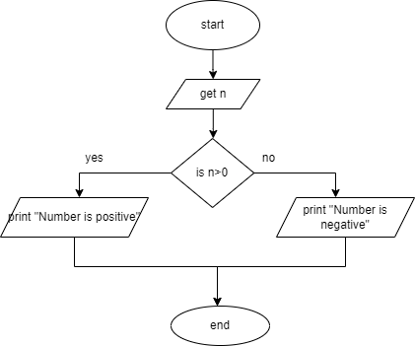

**Pseudocode:**

BEGIN

READ num

IF (num>0) THEN

DISPLAY num is positive

ELSE

DISPLAY num is negative

END IF

END

**7. Write an algorithm, flowchart and pseudocode for to check odd or even number.**

**Algorithm:**

**Step 1:** Start

**Step 2:** get num

**Step 3:** check if(num%2==0) print num is even

**Step 4:** else num is odd

**Step 5:** Stop

**Flowchart:**

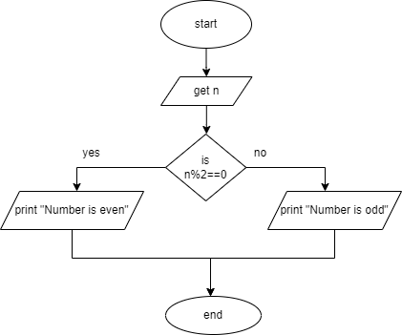

**Pseudocode:**

BEGIN

READ num

IF (num%2==0) THEN

DISPLAY num is even

ELSE

DISPLAY num is odd

END

**8. Write an algorithm, flowchart and pseudocode to check greatest of three numbers.**

**Algorithm:**

**Step1:** Start

**Step2:** Get A, B, C

**Step3:** if(A>B) go to Step4 else go to step5

**Step4:** If(A>C) print A else print C

**Step5:** If(B>C) print B else print C

**Step6:** Stop

**Flowchart:**

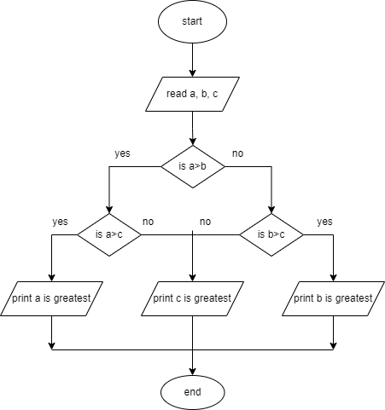

**Pseudocode:**

BEGIN

READ a, b, c

IF (a>b) THEN

IF(a>c) THEN

DISPLAY a is greater

ELSE

DISPLAY c is greater

END IF

ELSE

IF(b>c) THEN

DISPLAY b is greater

ELSE

DISPLAY c is greater

END IF

END IF

END

**9. Write an algorithm, flowchart and pseudocode to check whether given number is +ve, -ve or zero.**

**Algorithm:**

**Step 1:**Start

**Step 2:**Get n value.

**Step 3:**if (n ==0) print “Given number is Zero” Else go to step4

**Step 4:**if (n > 0) then Print “Given number is +ve”

**Step 5:**else Print “Given number is-ve”

**Step 6:**Stop

**Flowchart:**

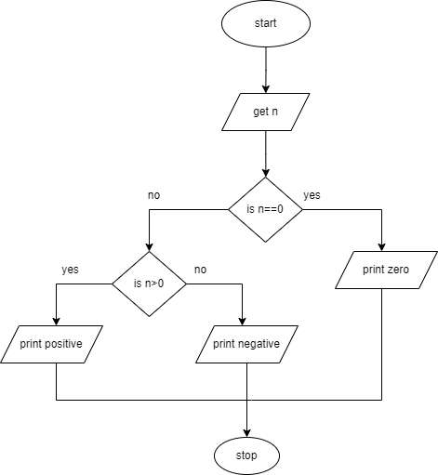

**Pseudocode:**

BEGIN

GET n

IF(n==0) THEN

           DISPLAY “n is zero”

ELSE

           IF(n>0) THEN

           DISPLAY “n is positive”

ELSE

            DISPLAY “n is positive”

END IF

**10. Write an algorithm, flowchart and pseudocode to print all-natural numbers up to n.**

**Algorithm:**

**Step 1:**Start

**Step 2:**get n value.

**Step 3:**initialize i=1

**Step 4:**if (i<=n) go to step 5 else go to step 8

**Step 5:**Print i value

**step 6:**increment i value by 1

**Step 7:**go to step 4

**Step 8:**Stop

**Flowchart:**

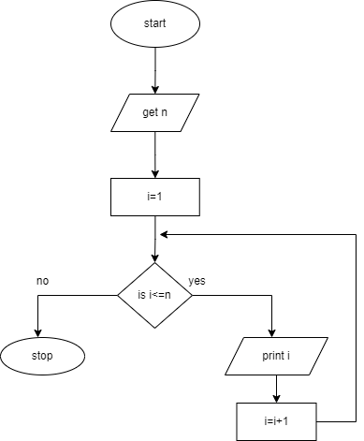

**Pseudocode:**

BEGIN

GET n

INITIALIZE i=1

WHILE(i<=n) DO

PRINT i

i=i+1

ENDWHILE

END

**11. Write an algorithm, flowchart and pseudocode to print n odd numbers.**

**Algorithm:**

**Step 1:** start

**Step 2:** get n value

**Step 3:** set initial value i=1

**Step 4:** check if(i<=n) go to step 5 else go to step 8

**Step 5:** print i value

**Step 6:** increment i value by 2

**Step 7:** go to step 4

**Step 8:** stop

**Flowchart:**

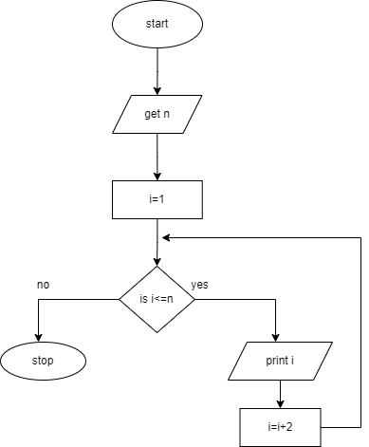

**Pseudocode:**

BEGIN

GET n

INITIALIZE i=1

WHILE(i<=n) DO

           PRINT i

           i=i+2

ENDWHILE

END

**12. Write an algorithm, flowchart and pseudocode to print n even numbers.**

**Algorithm:**

**Step 1:** start

**Step 2:** get n value

**Step 3:** set initial value i=2

**Step 4:** check if(i<=n) go to step 5 else go to step8

**Step 5:** print i value

**Step** **6:** increment i value by 2

**Step 7:** go to step 4

**Step 8:** stop

**Flowchart:**

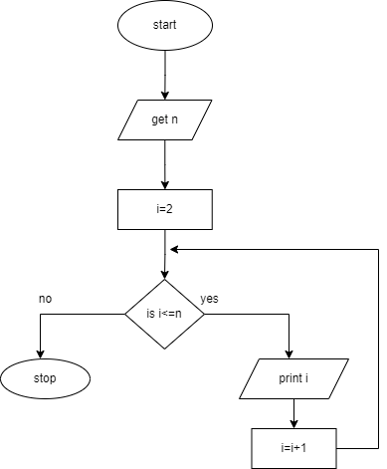

**Pseudocode:**

BEGIN

GET n

INITIALIZE i=2

WHILE(i<=n) DO

           PRINT i

           i=i+2

ENDWHILE

END

**13. Write an algorithm, flowchart and pseudocode to print squares of a number.**

**Algorithm:**

**Step 1:** start

**Step 2:** get n value

**Step 3:** set initial value i=1

**Step 4:** check i value if(i<=n) go to step 5 else go to step8

**Step 5:** print i*i value

**Step 6:** increment i value by 1

**Step 7:** go to step 4

**Step 8:** stop

**Flowchart:**

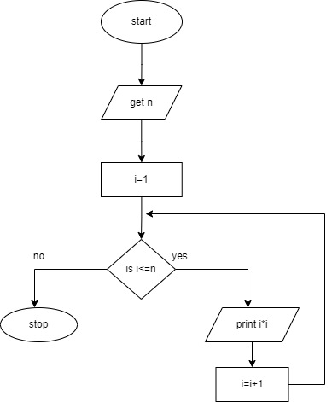

**Pseudocode:**

BEGIN

GET n

INITIALIZE i=1

WHILE(i<=n) DO

           PRINT i*i

           i=i+2

ENDWHILE

END

**14.Write an algorithm, flowchart and pseudocode to print to print cubes of a number.**

**Algorithm:**

**Step 1:** start

**Step 2:** get n value

**Step 3:** set initial value i=1

**Step 4:** check i value if(i<=n) go to step 5 else go to step8

**Step 5:** print i*i *i value

**Step 6:** increment i value by 1

**Step 7:** go to step 4

**Step 8:** stop

**Flowchart:**

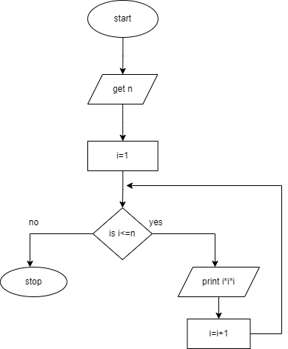

**Pseudocode:**

BEGIN

GET n

INITIALIZE i=1

WHILE(i<=n) DO

           PRINT i*i*i

           i=i+2

ENDWHILE

END

**15.Write an algorithm, flowchart and pseudocode to find sum of a given number.**

**Algorithm:**

**Step 1:** start

**Step 2:** get n value

**Step 3:** set initial value i=1, sum=0

**Step 4:** check i value if(i<=n) go to step 5 else go to step8

**Step 5:** calculate sum=sum+i

**Step 6:** increment i value by 1

**Step 7:** go to step 4

**Step 8:** print sum value

**Step 9:** stop

**Flowchart:**

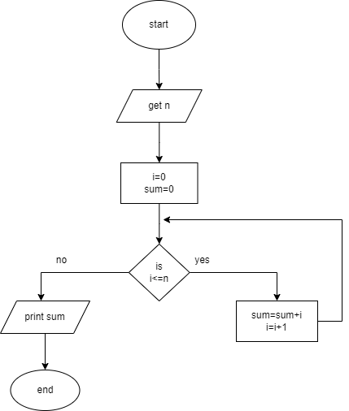

**Pseudocode:**

BEGIN

GET n

INITIALIZE i=1, sum=0

WHILE(i<=n) DO

           sum=sum+i

           i=i+1

ENDWHILE

PRINT sum

END

**16.Write an algorithm, flowchart and pseudocode to find factorial of a given number.**

**Algorithm:**

Step 1: start

step 2: get n value

step 3: set initial value i=1, fact=1

Step 4: check i value if(i<=n) go to step 5 else go to step8

step 5: calculate fact=fact*i

step 6: increment i value by 1

step 7: go to step 4

step 8: print fact value

step 9: stop

**Flowchart:**

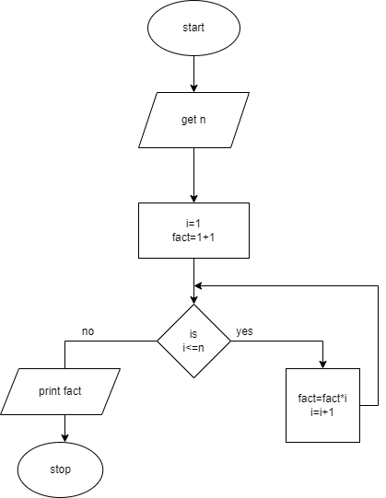

**Pseudocode:**

BEGIN

GET n

INITIALIZE i=1, fact=1

WHILE(i<=n) DO

           fact=fact*i

           i=i+1

ENDWHILE

PRINT fact

END